EFOOD

UI_Prototype

Version <1.3>

Revision History

| **Date** | **Version** | **Description** | **Author** |
| --- | --- | --- | --- |
| 16/12/2022 | 1.0 | User Management, Product Management | Trần Dũng Tiến |
| 16/12/2022 | 1.1 | User Profile, Contact & Location page | Trần Anh Khôi |
| 16/12/2022 | 1.2 | Shopping Cart | Đinh Cao Hồng Phước |
| 21/12/2022 | 1.3 | Dashboard management, Product management | Trần Bảo Long |
|  |  |  |  |

Table of Contents

UI_PROTOYPE

1. **Admin UI:**
2. **Dashboard Management**

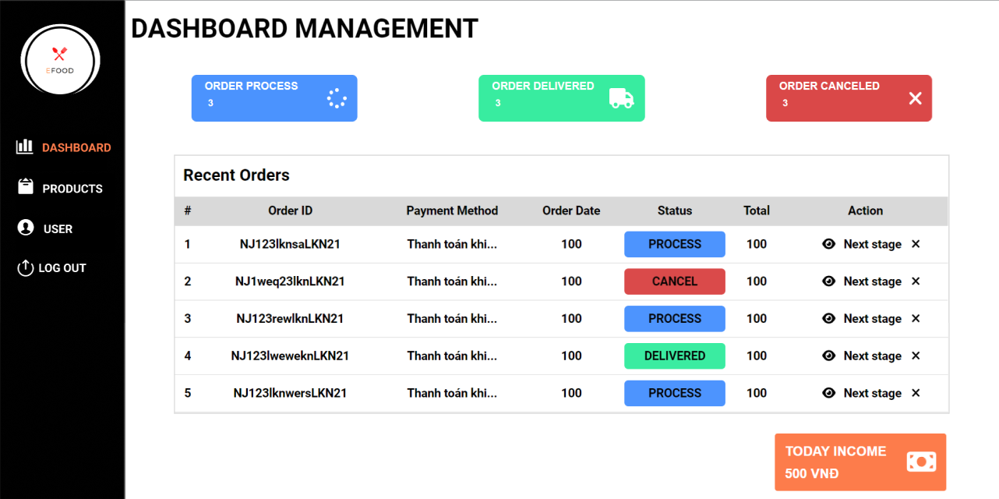

**Description:**

The Dashboard page shows all the bills of the customer. It includes all invoices from all customers who have ordered food on this website. In this list, the admin can delete the bill when clicking the icon (X), adjust the delivery status when clicking the eye icon and also calculate the income of all bills. Besides, when clicking the status on the top, the list is filtering the bill suitable with delivery status.

1. **Contact Management**

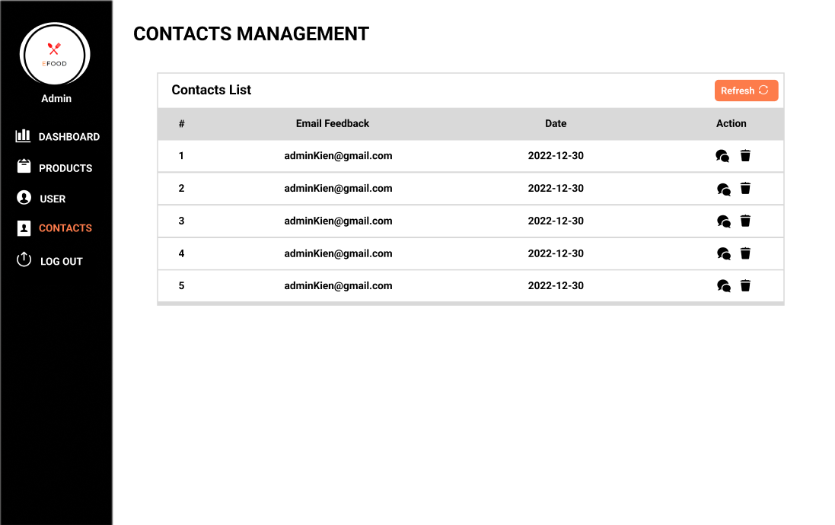

**Description:**

The contact management page: the process of recording contacts' details and tracking their interactions with a business. In this list, the admin can delete the contact when clicking the icon (bin), watch contact content when clicking the icon (comments).

1. **Product Management**

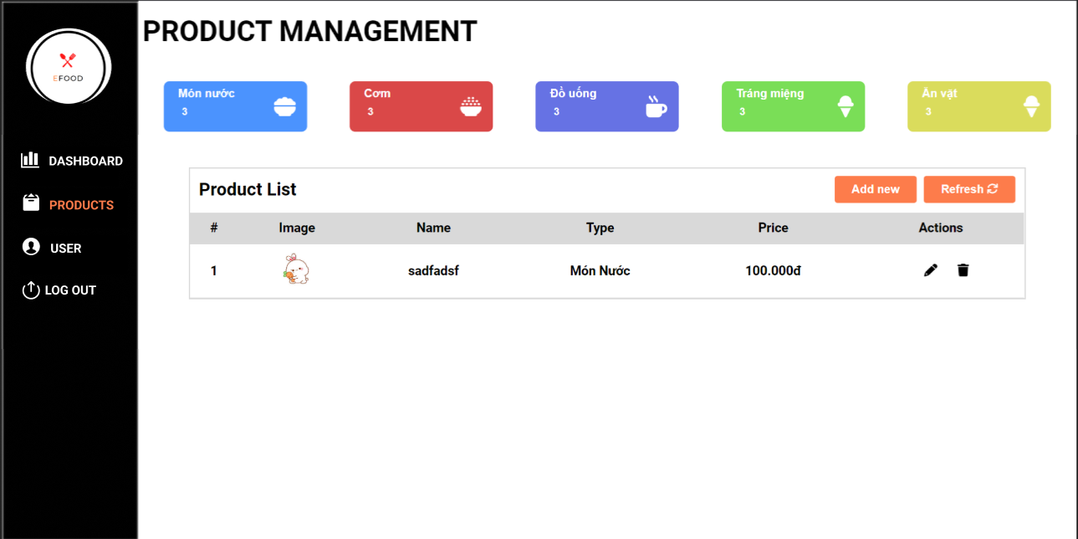

**Description:**

The Products Management page shows all the products of the website. It includes the category of all products and the quantity of each category. In the Product List, admin can add a new product for the website, when adding successfully the product will display in the product list and the menu in customer page. The admin also can change image, name, type, price of product when clicking the pencil, and delete a product when clicking the trash bin ( of course it will affect the database).

1. **User Management**

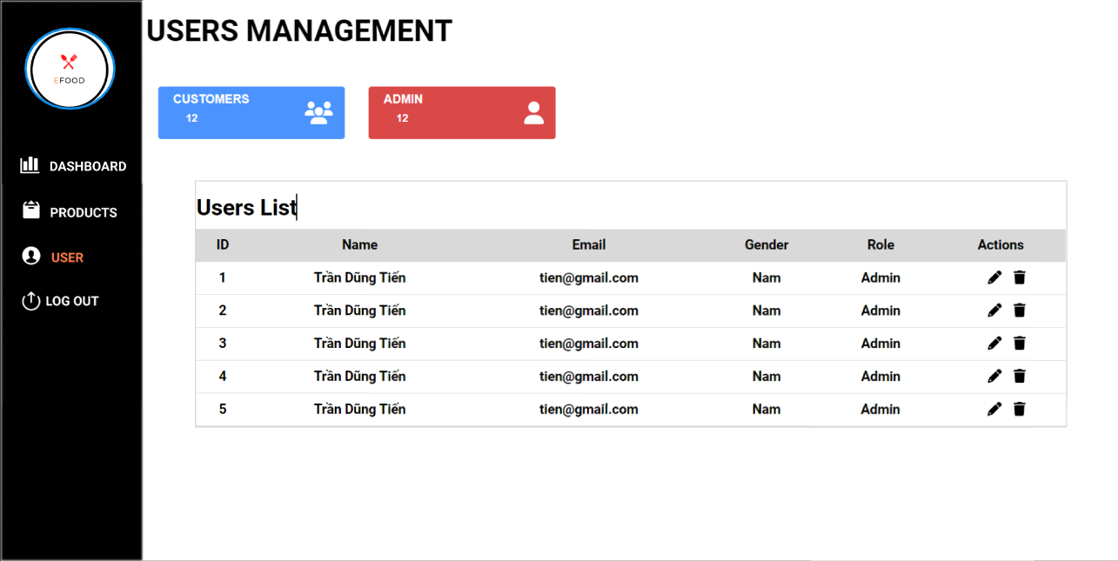

**Description:**

The Users Management page shows all the users of the website. It includes the category of all users and the quantity of each category. In the Users List, the admin can change the role of the user when clicking the pencil (Admin or Customer), and delete a user when clicking the trash bin ( of course it will affect the database).

**2. Customer UI:**

1. **Log In/ Register:**

* Log In:

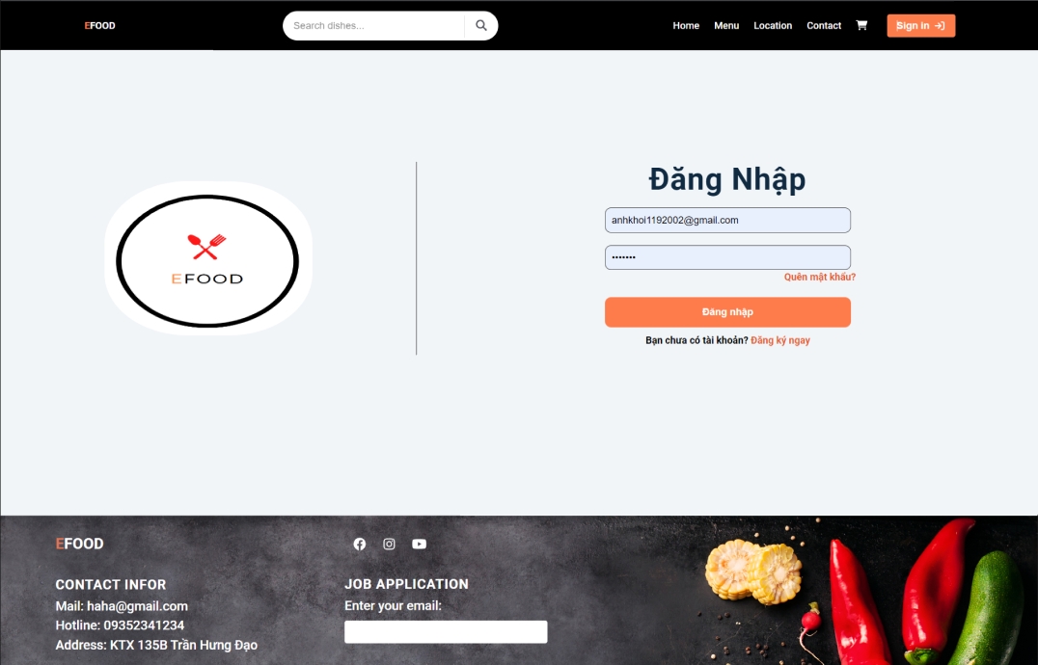

**Description:**

The login page allows a user to access a website or web application by entering their username and password or by authenticating with a social network login. In addition, the page allows you to enter both authorized users and those who first visited the site and need to register by clicking “Đăng kí ngay”. When you forgot your password, you can click on “Quên mật khẩu?” to change your password.

* Register:

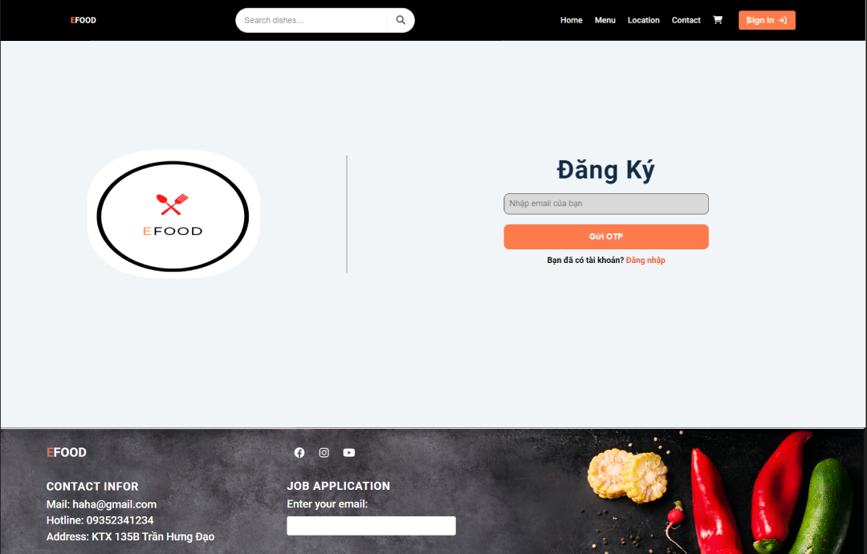

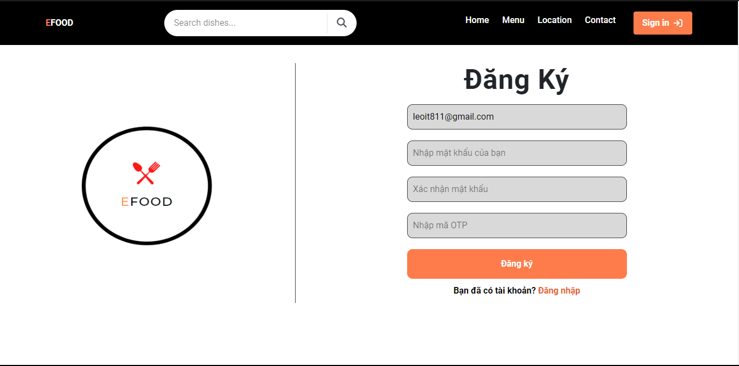

**Description:**

A signup page (also known as a registration page) enables users and organizations to independently register and gain access to this system. When you input your Email and send OTP. If complete, a registration form is shown. And you can sign up for a new account with the correct OTP. If valid, you must re-input your email because it’s not correct.

1. **Home:**

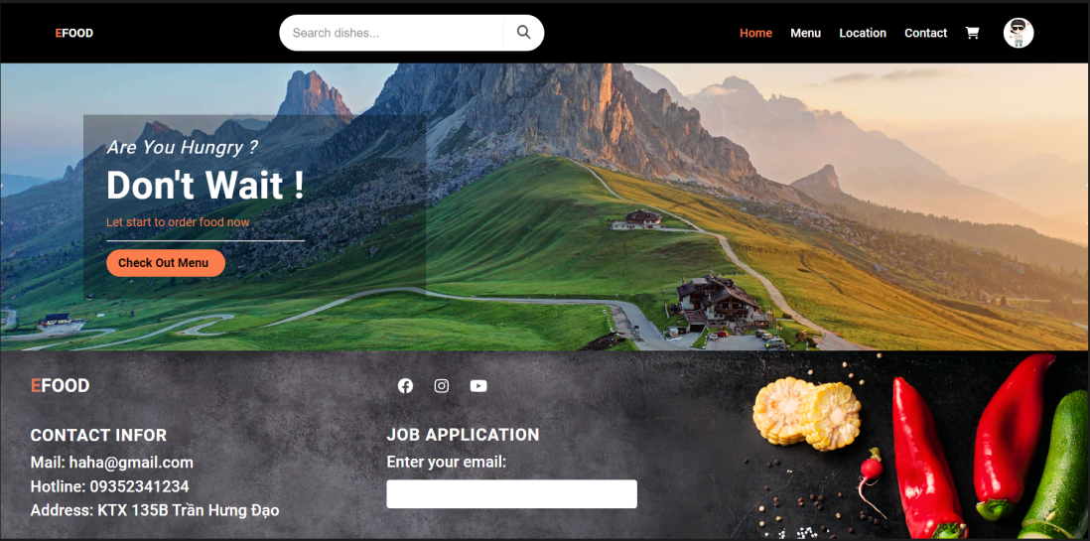

**Description:**

A home page is the primary web page that a visitor will view when they navigate to a website via a search engine, and it may also function as a landing page to attract visitors.. When you click on “Check Out Menu”, this page will link to the Menu page.

1. **Menu:**

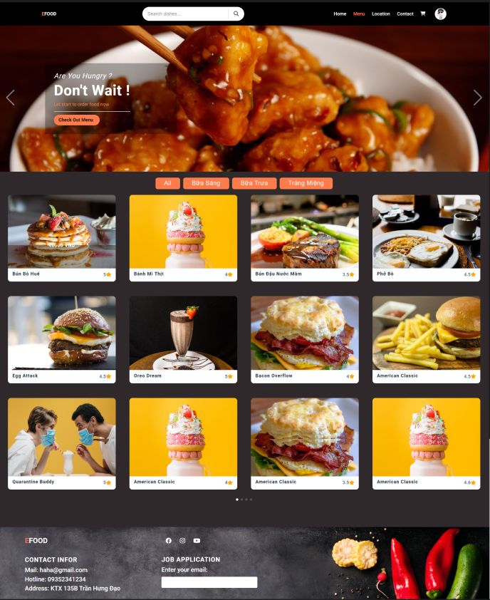

1. **Shopping cart:**

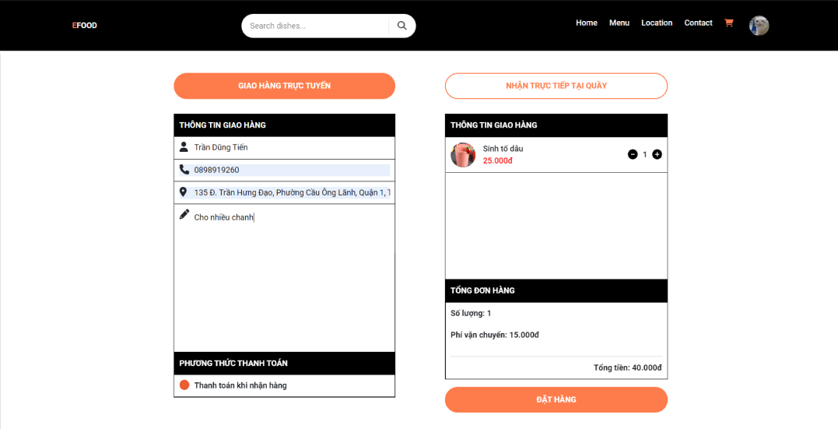

**Description:**

The shopping cart page shows all items that customers added in the Menu page and delivery information. At the top of the page, there are two buttons to change delivery methods. The left table is delivery information. You have to fill it first to order. The right table is a list of all items that customers added. You can change the quantity of an item by clicking on the plus and minus button next to it. Finally, click on the button below the right table to order.

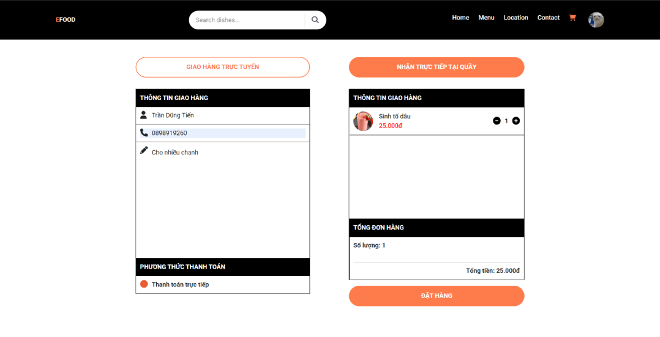

**Description:**

When change delivery method to “NHẬN TRỰC TIẾP TẠI QUẦY”, you don’t have to fill-out address, and the bill doesn’t have delivery cost.

1. **Rating**

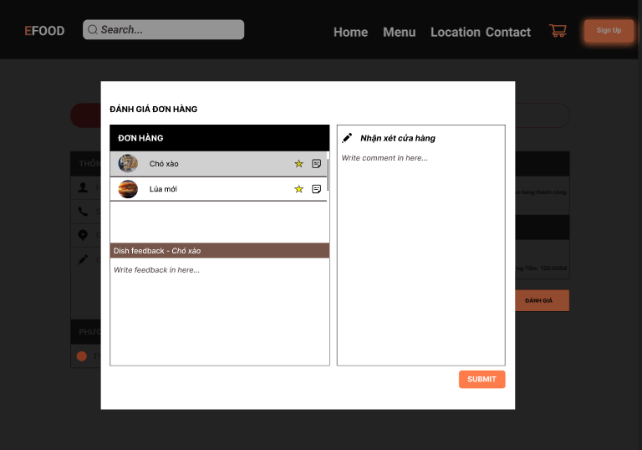

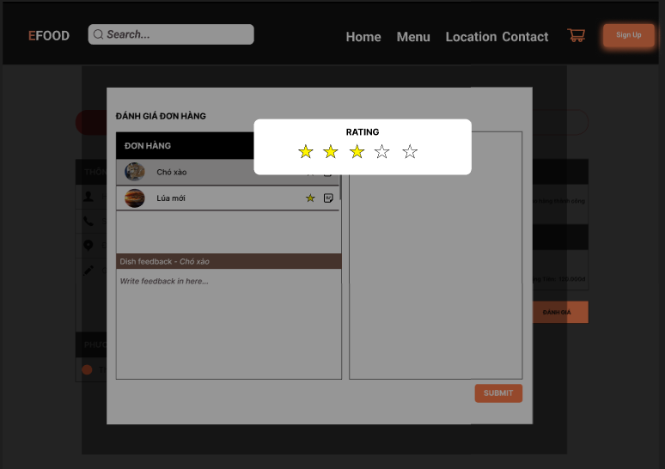

1. **Contact:**

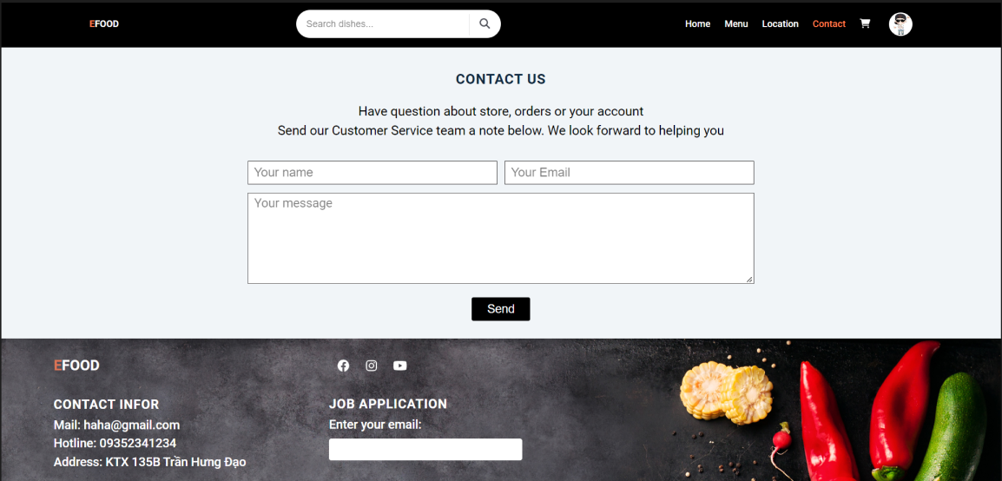

**Description:** The contact page allows users to make some comments or ask everything about the store including their job application, their complaints about the services. After sending your messages are sent to system email. And there is a response to their email from us.

1. **Location:**

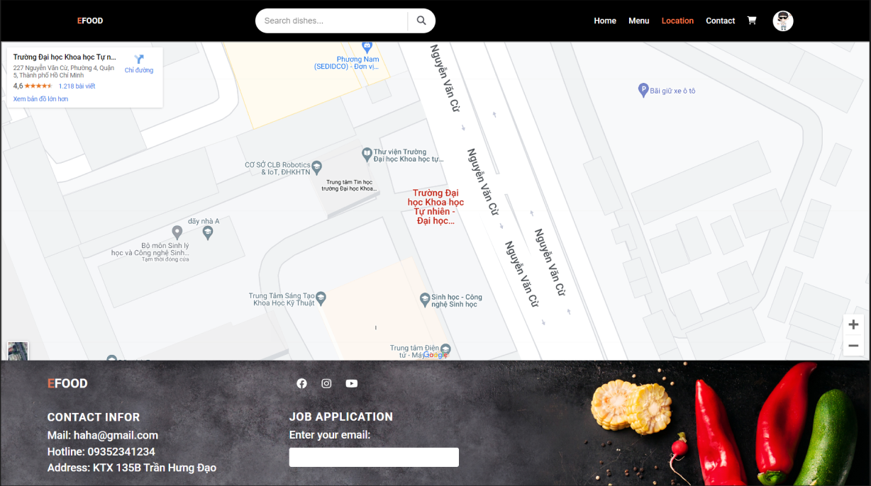

**Description:** The location page shows the location of the offline store, users can click the show direction in the top left corner to access the google map and see the distance and the direction showing ways from their location to the store.

1. **User Profile:**

* User profile:

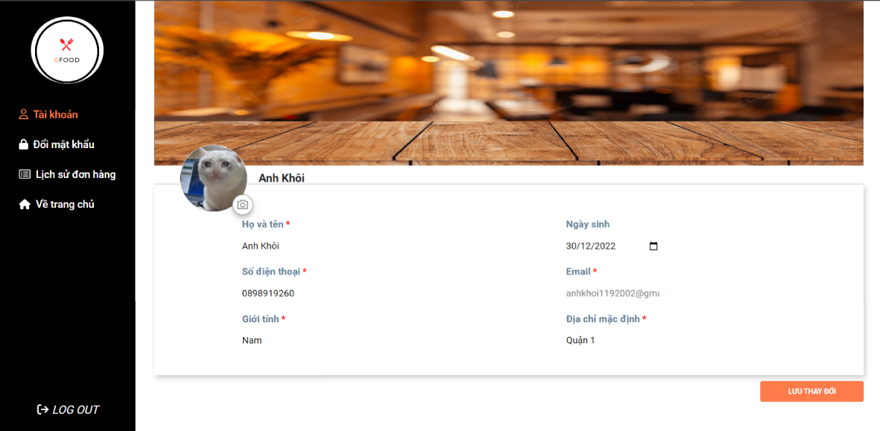

**Description:** This tab of the website shows the current user profile including personal information: full name, date of birth, gender, phone number, email and address. Users can change information in input fields including the avatar by selecting the symbol camera under the avatar. After changing, click the “Lưu Thay Đổi” to update new information.

* Change password:

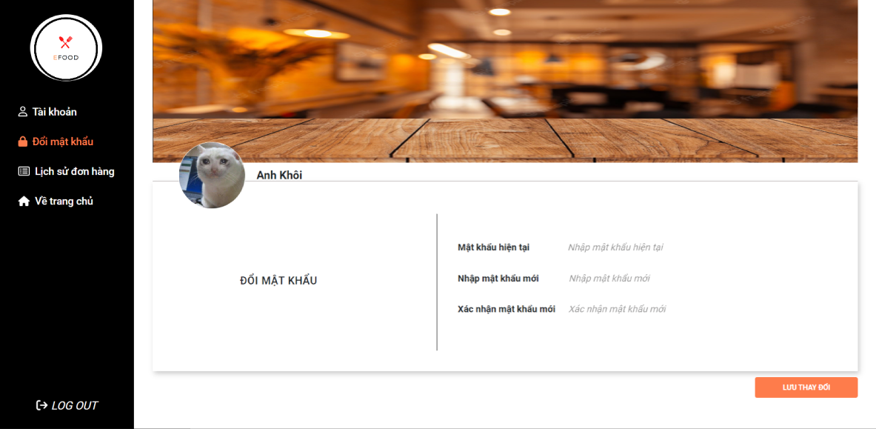

**Description:** This tab of the website changes new password to new password by inputting the current password, new password users want to change and confirm again that password with conditions such as: current password must be true, new password must be different from old password and the confirm new password must be right .After validation, click the “Lưu Thay Đổi” to update the new password.

* History payment:

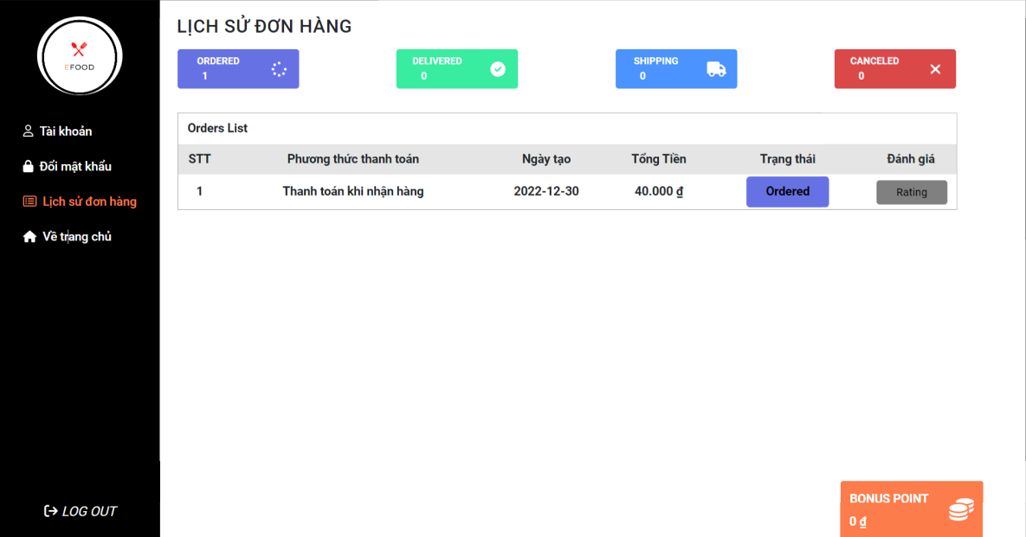

**Description:** This tab of the website shows the payment history of the users with the details of each order bill with number order, payment paythod, create day, status and total money of that bill. There are 4 statuses of the bill: ordered, delivered, shipping and canceled, the user can rate the delivered bill. Moreover, users can see their bonus point.

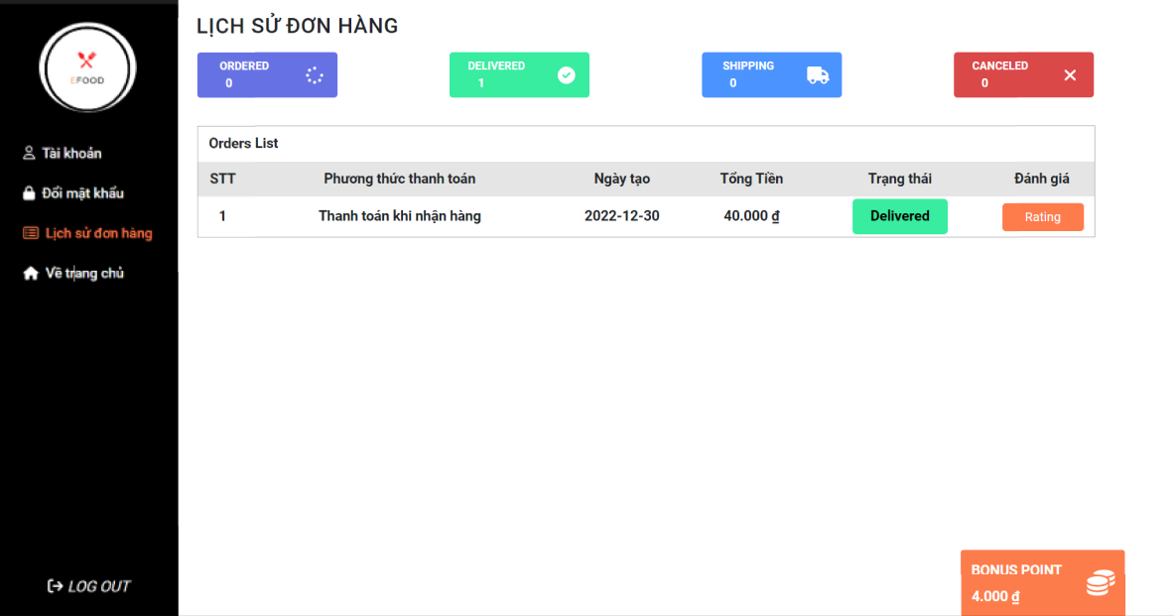

* Search Food:

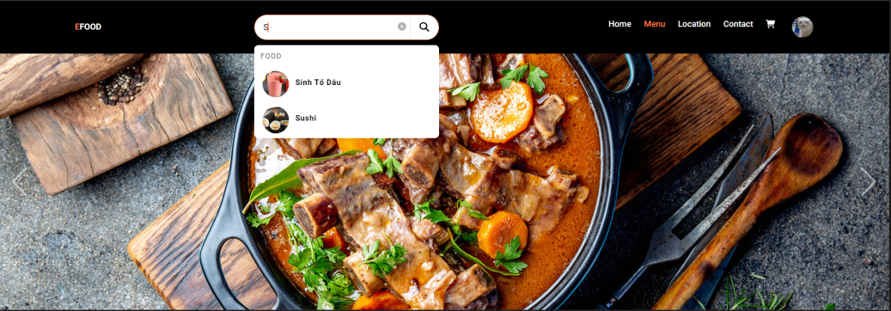

**Description:** Users input food name into search blank, foods with relative name will display like that. Click the food you want to buy, add food to the cart and it will appear. Enter the quantity of that food and click “Add To Cart”, food will be added to the shopping cart.

